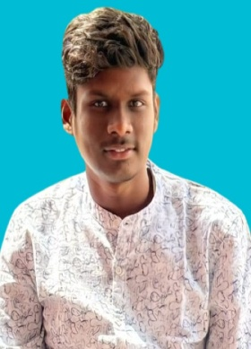 RESUME

**GADEWAR GANESH**

H.No. 2-5-24/2

Ashok road, Bhramawada

Adilabad.

Telangana-504001. Phone: 7569968110

Email: gadewarganesh2004@gmail.com

# CAREER OBJECTIVE

To secure a challenging position in an organization where I am effectively contribute my skill and potential as well as for the welfare and development of the organization.

# EDUCATION

|  |  |  |  |  |
| --- | --- | --- | --- | --- |
| **QUALIFICATION** | **UNIVERSITY** | **INSTITUTION** | **ACADEMIC YEAR** | **PECENTAGE** |
| **BSC-Agriculture** | VNMKV University | College of Agriculture, Parbhani. | 2025 | Pursuing |
| **Intermediate (BIPC)** | Board of Intermediate  Education | Telangana state residencial junior college, bellampalli. | 2022 | 89% |
| **SCC** | Board of Secondary  Education | Little flower english high school, Adilabad. | 2020 | 98% |

# STRENGTHS

* Good Communication Skills.
* Capability of Handling and Analyzing the Situation and Action According to it.
* Ability to Work with Team as well as Lead it.
* Have the Confidence of Making Difficult tasks Possible.

# ACCOMPLISHMENTS

* **Field work**: Participated in field visits and hands on training sessions, gaining practical experience in various agricultural operations, including pest control, irrigation management and harvesting techniques.
* **Workshops and Seminars**: Attended workshops and seminars on water and land management, enhancing understanding of the latest technologies and innovations in the field.
* **Extracurricular Activities**: Active member of National service scheme “NSS” participating in community on promoting cleanliness, Health camps, rural development, Special events.

HOBBIES

* Gardening.
* Reading books.
* Listening to music.

# PERSONAL PROFILE

Name : GADEWAR GANESH

Father’s Name : GADEWAR ATHUL

Date of Birth : 18-05-2004

Nationality : Indian

Religions : Hindu

Languages Know : English, Telugu, Hindi, Marathi

Gender : MALE

Marital Status : NO-Married

# DECLARATION

I hereby declare that the above-mentioned information is accurate to the best of my knowledge and belief.

Place: Adilabad you’re faithfully

Date: GANESH